RHSPT Trustees
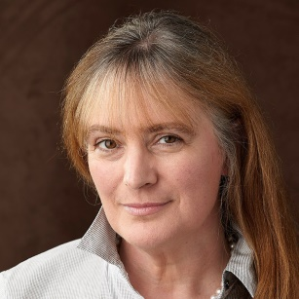
Amanda Forsyth FCA FCSI is a retired investment manager, having spent more than thirty years in the financial services industry. A keen amateur musician, she sings in the choir of St Giles’ Cathedral, Edinburgh where she is also a member of the Kirk Session and the Cathedral’s Treasurer. She has several other charity roles, including those of Chair at Live Music Now Scotland and Trustee of the RSNO Foundation.

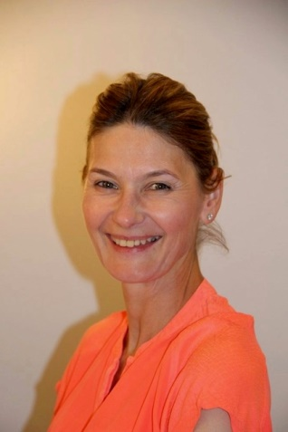
Carol Nimmo has a background in retail and owning & running a Finnish design business. She is now a Senior Iyengar Yoga teacher. As Chair of the local resident’s association which neighbours the Old Royal High School, Carol has been actively involved in saving the Building since 2014. More recently as Chair of the local New Town and Broughton Community Council she has campaigned against two hotel planning applications and represented the community at a Scottish Government Planning Inquiry in 2018 before the building was finally saved. Carol is delighted, through the Royal High School Preservation Trust, to now be able to play a part in its bright future.

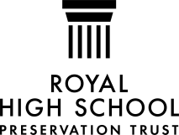

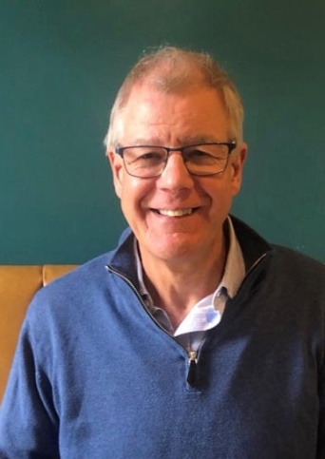
Colin Liddell WS – a retired accredited specialist in Charity Law (the first one accredited in Scotland), co-author of A Practical Guide to Charity Law in Scotland, author of local histories, current or former Chair and/or Trustee of a number of charities, including Dunard Fund, IMPACT Scotland, National Centre for Music, Perth & Kinross Heritage Trust, Pitlochry Festival Theatre, and Scottish Grantmakers, and currently involved with building projects for charities in Scotland with a total cost in excess of £200m.

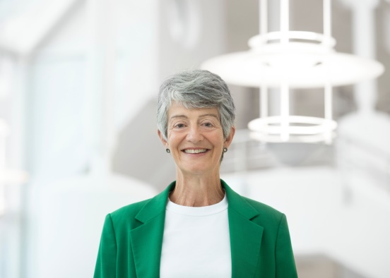
Nicola Gordon has held a number of non-executive roles in the public, private and voluntary sectors and currently serves as a trustee of the Scottish Ensemble and Edinburgh Printmakers as well as the Royal High School Preservation Trust. She is chair of the audit and risk committee on the board of the Scottish Environment Protection Agency and is a member of the board at the Scottish Energy Forum and OKEA A/S, a Norwegian energy company. Nicola is a chartered engineer and has extensive experience of leading capital projects and operations from her former career as an executive in the international energy sector.

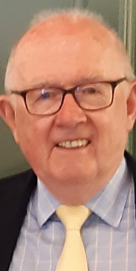
Richard Austin After studying Law and History of Art at Edinburgh University, Richard entered private practice as a solicitor, in Edinburgh. He subsequently became secretary of a major grant-making foundation. He has, over more than 20 years, sat on the board of a range of charitable organisations, joining the board of the RHSPT in 2015. Richard was a pupil at the Royal High School and, as a musician, was a regular performer in its magnificent hall.

