

NATIONAL CENTRE FOR MUSIC
Recruitment: Executive Assistant

JOB TITLE Executive Assistant
CONTRACT 1 year fixed-term contract, with the possibility for extension
SALARY £27,000 (pro rata @ 0.5 = £13,500 or 0.6 = £16,200)
HOURS 0.5 or 0.6 FTE
LOCATION Hybrid (preferably at least 2 days/week in offices in central Edinburgh)
REPORTS TO Chief Executive & Creative Director
START DATE As soon as possible (three-month probation period)
BENEFITS Auto-enrolment pension
31 days annual leave inclusive of public holidays pro rata

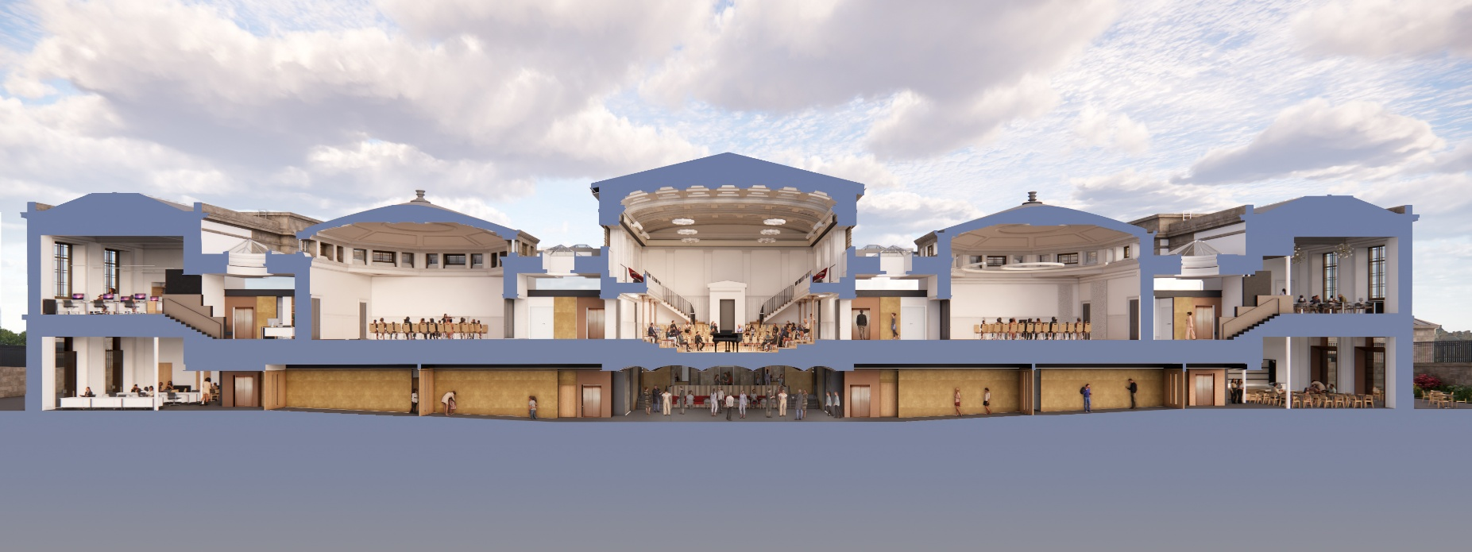

SUMMARY
The National Centre for Music (NCM) is a new charitable organisation which will take up home within and operate the iconic old Royal High School at the foot of Edinburgh’s Calton Hill. Offering new mid-scale performance and rehearsal spaces, practice rooms, a recording studio, co-working and creative office space, events and conferencing facilities, a cafe and bar, and two acres of flower-filled landscaped gardens - the first public city centre gardens to be opened in Edinburgh in 200 years – the centre will become an iconic destination and a place where Scotland's musical history is made.
The site is currently managed by the charity Royal High School Preservation Trust (RHSPT), who are leading a major construction project to reawaken this significant Scottish heritage site. When the capital project is completed, the National Centre for Music will become the tenant, (with operations expected to start in 2028).
The National Centre for Music is in start-up phase, developing its systems, team, programming and business model. With a bold ambition to be a home for all of Scotland’s musical communities and to create an environment where Scottish musical history is made, this is a fast-paced environment and a period of rapid change and growth.
We are seeking a dynamic, pro-active and detail-orientated Executive Assistant to support our developing team, help embed strong administrative systems and company policies, ensure good internal communications and generally be a responsive and practical pair of hands on general administrative functions.
This is a role for someone who understands that pre-operational organisations are dynamic by nature. Priorities will shift, systems will evolve, and there will be moments of ambiguity alongside moments of excitement and momentum.
In return, the role offers:
- The chance to help shape an inclusive and productive culture from the beginning
- Close collaboration with senior leadership and strategic decision-makers
- Exposure to the early phases of establishing a music organisation and venue
- A meaningful opportunity to contribute to a project with long-term cultural impact
This is initially a 1-year post, supporting the team at a period of transition, but we anticipate it may extend beyond this. We are open to flexible working arrangements and for hours to be spread across more than 3 days. While the role will have hybrid conditions, good contact time with the senior management team is essential.
We’re excited to find a candidate who can get stuck in.

ABOUT the NATIONAL CENTRE FOR MUSIC
VISION
Reawakening a spectacular Scottish heritage site, the National Centre for Music will become an energising force in Scotland’s music sector, and an iconic cultural destination. Through our programmes and partnerships, Scotland’s musical communities will come together, music will change peoples’ lives, and Scotland will stay firmly at the forefront of global musical boldness.
MISSION
To create a nurturing and inspiring environment where Scottish musical history is made.
VALUES
Every sound counts
The explosion of different types of musical approaches, genres and passions that exist here every day is what makes us special.
Curiosity fuels our creativity
Our quest to celebrate the richness of music making in Scotland will never be exhausted – we know there is always more to discover, and we take that challenge seriously.
Join the dots
We are an active connector - bringing different musical perspectives and knowledge together in respectful exchange for everyone’s benefit.
Warm and welcoming
We may look grand on the outside, but as soon as you enter, you feel at home. Our spaces all have an uplifting atmosphere, and our friendly team ensure everyone can access, enjoy and participate fully in what we have to offer.
Building for the future
We are creating an organisation that will play a significant role in Scotland’s cultural trajectory. People will start to rely on us, so we prioritise long-term resilience and put sustainability (in all its meanings) at the heart of our thinking, to ensure we become an organisation fit for the future.


RESPONSIBILITIES

We anticipate this role will involve…

Executive & Board Support
- Varied and responsive support for the Chief Executive and senior team
- Supporting a strong, productive relationship between the Board and executive team – you will support the preparation of clear, well-organised Board and committee papers and agendas, and effective minute-taking
- Managing diaries and scheduling, covering both internal and external meetings

Systems, Policies & Organisational Development
- Helping to design, document, and refine administrative systems in a new organisation
- Identifying and developing (with the Chief Executive) best practice organisational policy examples in line with NCM’s mission and style
- Setting up and maintaining clear and accurate records, including across action trackers, monitoring systems, and information management systems
- Assisting with the administration related to tender processes
- Contributing to ideas to improve how the team works as the organisation grows

Stakeholders, Communications & Events
- Being a welcoming and professional point of contact for the organisation across all communication channels
- Supporting meeting logistics including for virtual meetings
- Helping to deliver events such as launches, site visits, stakeholder consultations

Financial & Office Administration
- Supporting the Finance Manager to process invoices and expenses, and maintain accurate financial records
- Supporting with recruitment processes, ensuring candidates are cared for and supported with clear communications and information through the process
- Supporting with IT set up, particularly implementing new software
- General office administration, with a focus on creating a positive working environment
To achieve all of the above, the successful candidate will need to:
- Understand what makes efficient systems
- Have a keen eye for detail and a practical, logical approach to organising information
- Be a personable, friendly and proactive colleague
- Handle confidential information with care, discretion, and good judgement
We think the role would suit someone who:
- Has a genuine passion for the arts, and is inspired by the mission of the National Centre for Music
- Has experience in a busy office environment and feels comfortable with change, unknowns and developing new ideas
- Likes creating order, systems, and clear processes
- Is a fast learner and enjoys diversity in their tasks and remit
- Takes pride in being reliable, thoughtful, and supportive to everyone they work with

HOW TO APPLY
Please email hello@ncmscotland.org.uk with Executive Assistant as your subject header, attaching:
- a copy of your CV

- a covering letter of not more than one A4 page (or a short video or audio recording of not more than 4 minutes in length), outlining why you are interested in this position and highlighting experience relevant to the role. Please also give us a feel for your working style, and an indication of approximately when you would be able to start in post.
CVs and Covering Letters will be anonymised before review by the shortlisting panel. As indicated above, if you do not feel comfortable sharing a written submission, we are also happy to accept video or audio recordings of a covering statement. If you choose to submit a recording, the shortlisting panel will hear your voice (and, if you submit a video, know what you look like) but will not have access to your name or personal details.
Closing date - 12 noon on Monday 2 March 2026.
Interviews are expected to take place in the w/c 9 March.

If you have questions in advance of application, please don’t hesitate to contact us on hello@ncmscotland.org.uk and we will try to get back to you as quickly as possible.
EQUAL OPPORTUNITIES
We are committed to ensuring everyone has access to the same resources and opportunities in applying for this role. If you have any access requirements, or we can do anything to help you feel more supported in your application, please do not hesitate to contact us and we will make any reasonable adjustments we can.
To give everyone the best chance of demonstrating their suitability for the role, we will share the core interview questions a few days in advance of first interviews.

